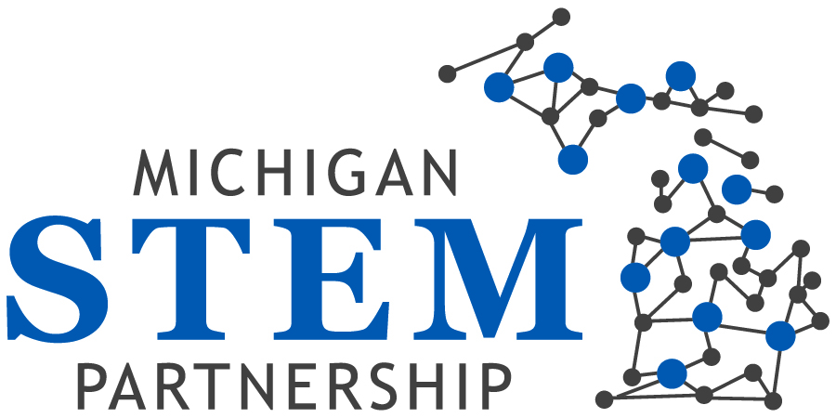

Minutes of Board meeting 5/22/14

Meeting convened at 12:17 p.m.

Attendees: Paul Agosta; Joe Asiala; Christy-Cloud-Webb; Patty Farrell-Cole; Mike Gallagher; Heather Gallegos; Gary Gilger; Alan Lecz; Brandon Lucas; Greg Marks; Michael Tanoff; Jodie Ledford, Barbara Bolin, Al Elyaderani,
On the phone: Vass Theodoracatos, Derhun Sanders, Victor Naidu, Jenny Schanker

Apologies: Patty Cantu, Bishop Gibert, Val Masuga, Mary Sutton

Guest Attendees: Joe Krajcik, Director of the CREATE for STEM Institute at Michigan State University

Public Comments: There were no public comments.

Consent agenda: The wrong file for the minutes of the March meeting were sent out prior to the meeting so approval was postponed until the July meeting.

Committees and Task Force Reports:
Executive Committee:
There was no report from the Executive Committee. The Chair reminded Board members that the Executive Committee will maintain its monthly meeting schedule, as will the other committees.
Finance Committee (Treasurer): Joe presented financial reports from the fiscal agent to the Board. Heather queried why the report showed that one hub had not received its $35,000 grants allocation and the ED explained that that error had now been corrected. Joe mentioned that $200,000 is reserved for the Board to use during the grants process.
The ED reminded the Board that all of the details of the awards process are available in a previous newsletter and on our website. She also mentioned that the total amount which was awarded during the first round of the grants process was just over $76,000. She added that three proposals were funded by the Board (out of the $200,000).
The ED reminded members that there are three deadlines for grant funding—September 1, December 1 and April 1, 2015.
Christy mentioned that some hubs have not yet completed reviewing round 2 grants.
Joe mentioned that each hub had $35,000 for their allocation. Any request beyond the $35,000 up to $200,000 needed board approval.
Reporting on the non-profit status work, the ED said that she had discussed the Articles for Incorporation procedure with Kristen Jones, the attorney assigned to the project. The ED reminded Board members that they had received the charter document that will form the basis for future by-laws of the organization. She asked that members review the document and return it with any comments or changes to her by June 15th.
Joe mentioned that the issue of possible conflict of interest has been brought up by some Board members.
He stated that Board members need to make involvement with other non-profit organizations clear to resolve potential conflicts.
Joe mentioned that while concern has been expressed about the Partnership seeking non-profit status, our goal is to bring more resources to the MI STEM Partnership.
Paul added that we know there are companies willing to donate money. It was stated again that as a Partnership, communication is the key and we need to have better communication with the hubs.
Michael Gallagher shared that to address concerns coming from the hubs we need to understand the history of the Network. The Partnership board needs to engage more with the hubs and we need to focus on the strengths of the Network to create more opportunities at the hub level.
Christy Cloud-Webb added that as a 501©3 we cannot lobby. Joe added that as a result of this conversation we need to concentrate on conflict of interests and communication and lobby issues.
Brandon added that we have to define the concept of partnership and what it means to be a partner.
Greg added that a relationship among the partners needs to be articulated.

At this time, the Board interrupted the agenda and the Chair welcomed and introduced Dr. Joe Krajcik to the Board.
After querying members about their knowledge and understanding of the Next Generation Science Standards, Dr. Krajcik decided to use his presentation time to provide details and updates on the NGSS.
He also discussed where Michigan stands in relation to other states.

Dr. Joe Krajcik Presentation:

Subject: An Introduction to the Framework for K- 12 Science Education and NGSS (Next Generation of Science Standards)

Dr. Krajcik discussed that he had been involved in the development process for the standards for 5 years. The first step was the creation a new framework for teaching and learning. Dr. Krajcik was the leader of the Physical Science Design team and he reminded members that all K-12 science students should have a solid knowledge of science. NGSS was created in order to reach this goal through creating required standards.
Michigan has not adopted these standards yet. He mentioned that there is not any federal money behind this project. He explained the goal is to ensure that science is accessible to all students.
Brandon asked about the assessment criteria and Joe discussed that the major requirement of an assessment is that it focus on three-dimensional learning, including:
- Scientific Engineering practices
- Blending of core ideas
- Cross crosscutting concepts
Dr. Krajcik reminded members that all of the documents for NGSS Assessment and summaries are available on the website.
He also mentioned that the Partnership Board has the credibility to talk to the State Board and Legislators to help to get NGSS adopted and push our state forward.
Patty Farrell-Cole reported that there is a bill which passed through from education through treasury and also there is another RFP associated with that which include small balance as a part of that. ??? I need to listen to the recording to find out more about this statement.
Joe Asiala shared that Joe Krajcik will be at the “Educators and Businesses summit for Professional Development” on October 3rd.
The ED mentioned that she needs to talk with MEDC regarding registration for sponsorship and see if they have a table available for us.

The Board returned to the planned agenda with limited time available.

Board Development Committee:
Christy shared that she had received only one application for open Board positions. She mentioned that the application is available on our webpage with all of the requirements and responsibilities of Board members.

Communication Committee:
Greg Marks shared that there are three things that need to be taken care of. We need:
- To share information about the strategic plan.
- To prepare a video tape or some sort of recording for this purpose
- To clarify the relationship between the hubs and prosperity zones. This is the subject that causes most confusion.
The Chair told members that we are not changing our hub structure. She also added that this needs to be communicated to every hub.
Jodie added that at the hub level they don’t know who should be the lead STEM contact when working with others in the prosperity regions on grants etc. Christy pointed out that the hub contacts are listed on the hub pages on our web site.
Paul added that the interaction process needs to be explained to the hubs and we also need to get feedback on activities in the prosperity regions.
Jodie added that even though we have the contact information on our website people still don’t know who they should contact.
The ED mentioned that the concept of trying to get economic development, workforce development and education agencies to work together is very difficult and takes time.
Board Task Force:
Brandon provided an update on the grants. Brandon asked the ED to prepare a report regarding proposals and their results.
The ED mentioned that that update will be on the website shortly.

The ED added that perhaps we need to add a comment in future RFPs that incomplete applications will not be reviewed.

Strategic Direction:
Paul shared that the strategic direction committee identified prioritized strategies under our goals. Now we are looking for feedback to make sure we have a collaborative effort and buy-in across the Partnership. Our goal is to create a consensus. The ED shared that she had talked to three hubs and that she explained to the hubs that additional funding could be achieved if the Partnership gains non-profit status, and there should not be competition between the Partnership and the Network. She said that we are trying to make the funding pool bigger in order to grant more money to the hubs.
Paul shared that we are going to get feedback from Network directors from their quarterly meeting.
Greg shared that if the Partnership intends to include K-12 we need to work closely with the Network and the Math and Science Centers.

Executive Directors report:
Due to the shortness of time, the Chair asked that the written reports submitted prior to the meeting be accepted.
The ED reported that she has a meeting on June 3rd with Mary Starr, the ED of the Network to discuss collaboration, possibly on a grant.
The ED also added that Friday June 13th is the next Board /Hub phone call.

Jodie asked about substitution of Google Docs for Basecamp and the ED made it clear that the Partnership will continue to pay for Basecamp for those hubs that use it.
The Chair mentioned that we need to improve the Google Docs structure and make sure that we all know how to use it.

Next meeting: July 24, 2014

The meeting adjourned at 3:20 p.m.

--

