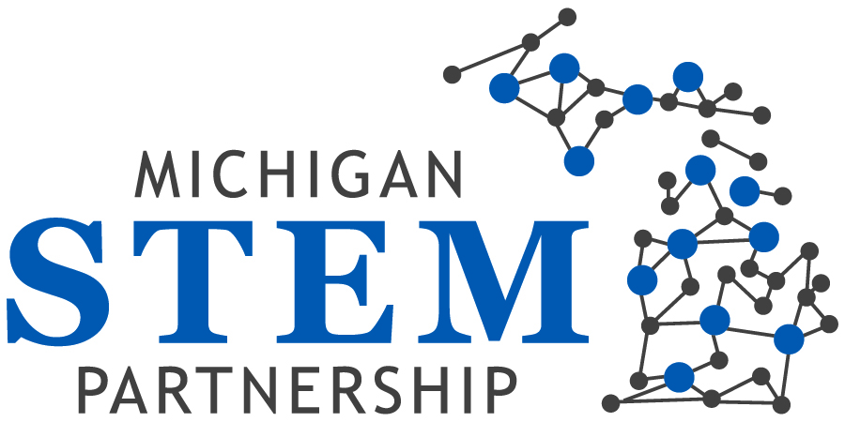

Minutes of Board meeting 12/18/14

Meeting convened at 12:12 p.m.

Attendees: Paul Agosta, Jodie Ledford, Christi Cloud-Webb, Alan Lecs, Gary Gilger, Greg Marks, Valarie Masuga, Lisa Gordon, Ali Elyaderani
On the phone: Greg Johnson, Heather Gallegos, Mary Sutton, Jennifer Hagerman, Brandon Lucas, Tom Wessels
Apologies: Derhun Sanders, Mike Tanoff, Patty Cantu, Jenny Schanker,
Guest Attendees: Nikki Rogers

Public Comments: Alan Lecz resigned from the board and introduced Lisa Gordon as his replacement.

Consent agenda: The minutes of the December meeting did not approve.

Call to Order (~5min) ED
Welcome Members and Guests ED
Meeting Protocol ED
Updates from Hubs:
Valerie mentioned that they had confirmation for their funding.
ED mentioned that she had confirmation from Libby that the funds for this coming year (fund 997) should be available at Wayne Resa by the end of December 2014. ED added that fund would be distributed to each hub shortly after budget plan for each hub completes.
ED also added that Hubs should fill-out the budget forms and return them back to the board in order to receive their funds.
Greg Johnson mentioned that they have meeting on Friday with governance group.
Paul recommended that if executive committee agrees, it is appropriate that Hubs have some preliminary documents which explain about the Board discussions, expectations and thoughts regarding the grant process. These documents could help Hubs to be able to make some critical decision.
ED explained the amount of the funds for each hub is around $5000. ED reminded hub leaders that in order to receive the funds they should fill-out their budget form first.
Regarding grant process and its criteria, Jodie asked if people still can use the old grant criteria from the website as a protocol until the new grant process and its criteria approve by the board. ED said they can use it.
For Straight Hub, Tom mentioned that he is also attending to the Wayne Resa meeting.
For the Bay Hub, Greg Marks mentioned that they had posting for a half time director position. They had a very good applicant pools. He said interview process will starts by 2015.
For Saint Clair Hubs, Greg Johnson mentioned that on November 13th, they had a STEM hub event. This event was concentrated on creating STEM pipeline, STEM jobs, and prediction for future job opportunities. He also mentioned they will have another STEM event on March 24th (concentrated on CTE), 2015. He also said they have another meeting tomorrow and they will work on grant updates, promotion of science standards and planning for March 24th.
For Lake Michigan Hub, Mike Tanoff was not attending. On behalf of Mike, ED reported that they are revising their charters and mission of the hub to be aligned with the STEM standards and partnership goals. They are also working on a flyer to promote their hub. On the next hub event they are going to ask Senator Palmer to give update about ongoing promotions.
Announcement
Alan Lecz resigned from the board and introduced Lisa Gordon as his replacement. He mentioned that Lisa has many experience with youth which could help partnership to attain its goals.
Committee Updates:
Paul mentioned that executive committee has engaged with legislatures and governor office. As a result of those engagements, they recommended us to collaborate more as a team in order to determine what we need to share with governor’s office and legislatures. He also mentioned that they had a meeting with senator Proos and Christy on the behalf of the executive committee discussed about legislative STEM promotion programs.

Jodie added that in a national evaluation, Michigan has been recognized as one of the states with the most organized hubs activities. So in order to continue STEM activities, we need to receive money and put it into those hubs. Jodie also asked if MI STEM Partnership is still an active member of the STEM-x foundation and ED answered yes.
For strategic direction, Brandon mentioned that the committee will update the board on January meeting.

For Governance committee, Gary mentioned; they sent out the job posting to everyone. For ED selection process, they created a selection committee including Gary, Greg, Paul, Nikki and Mike Tanoff. The job posting will be open until January 16th and after selecting top ten applicants, they will interview them on the second week of February. The selected candidate will start on March.
For 501C3, Gary mentioned that any non-profit organization needs to file 990 tax returns. We need an accountant to file this form for us. He added that, we already have many of required documents on hand and we may be qualified for an expedite option.
ED explained that the process may take about six months. She added that last year our lawyer filed the form for us to become an incorporated organization and currently we are an entity.
Paul asked if the board needs to take an action in order to let the 501C3 process move forward. Heather mentioned that we already took a vote on the board which let the board to move forward and there should not be any obstacle for any further decisions. Paul asked if this action let the ED to move forward and start working with an accountant.
Heather explained that the action was a general approval to move forward on 501C3.
Communication Committee:
For communication committee, Heather will update the board in January meeting.
Update from STEMx Change (~20min) Mary Sutton, Nikki Rogers, ED

ED mentioned that she attended the Ohio meeting with Mary Sutton and Nikki Rogers. The meeting had been held in Columbus, Ohio. She said several states attended to this conference and we discussed our 501C3 situation with California and Kentucky STEM Representatives. They recommended us to continue with giving out small grants for almost three years to get our name up there. Nikki explained about the ways some states focused on careers and created STEM schools instead of STEM certification. For instance, Kentucky partnered with Toyota to create programs that focused on Kaizen methodology (Continual improvement). Through these programs, students are sponsored to technological colleges for associate degree with specific skills and the classes are located in manufacturers. In Pennsylvania they are focusing on professional development and manufactures. All three states have STEM schools with STEM application process. In that application they allow all students to apply and build their career pathways through STEM.
ED mentioned that we have no certified STEM schools in Michigan and the State of Michigan is working on the process of issuing the certificate criteria through department of education.
Jodie asked if we could get more information about criteria.

STEM Standards Presentation (~30-40min) Nikki Rogers
Nikki Roggers is a STEM consultant. She currently works at Office of Technical Education at State of Michigan. She explained about The Relationship between business and industry through Career and Technical Education (All of the documents presented at this presentation are available for your review on Michigan STEM Partnership Google Drive).

Break
Break at 1:55 P.M. to 2:11

For the last part of the agenda, ED mentioned that board needs to determine the strategic direction of the board for 2015. She also reminded that based on October meeting decision, board decided to continue its meeting every month. She said board need to take a vote to decide if they are going to stick to the current decision or change it to every other month meeting agenda. Paul recommended to take the vote later.
Paul mentioned that executive committee had a conversation with a consultant regarding structure of the board and how to act more effectively. He added that we all need to become a part of the fund raising programs.
Regarding grant process, Brandon said that first we need to determine our goals for next year. Then, strategic direction committee can draft criteria.
Paul mentioned that governor office asked us for comment on STEM standards. He added that as a board we need to support and promote standards for STEM education.
Jodie recommended that for incorporate fund raising and following our NGSS (Next Generation Science Standards), we can invite Dr. Joe Krajcik again to help with workshop and charge attendees for $5. By the end of the workshop, we can ask attendees to fill out our survey forms and let us know if they are agree to incorporate NGSS into the state of Michigan.
Paul said that hubs are part of the math and science network and they are advocate of this change.

Gary said we need to determine where the boards stand on NGSS, first we need to know our priorities.

Paul added that next generation of NGSS should work towards STEM education.

Jodie suggested the board to create a quick survey about NGSS and send it to both hubs and Michigan Career Educators and Employer Alliance. The results could help us to know what percentage of those people are supporting and then we can share the results with legislatives.
Paul – This is a great idea but we need to separate NGSS from common core.
Paul recommended that CTE people and Science people should work together to determine the process of NGSS.

ED asked if anyone is opposed that NGSS be some part of the grant application.

Jodie recommended that NGSS could be mentioned in grant application as a bonus not a requirement.
Jodie recommended that there are many grants available through federal and state funds that require employer financial participation (employer matching grants). So we need to mention this point in grant rubric.
ED asked committees if they need anything from the board to move on.
Greg Johnson added that Michigan Science Teachers Association has many conferences and our organization could become a partner with them.

ED asked if anyone opposed to have monthly meeting on fourth Thursday of each month. No one opposed.
Action was passed. Board decided to have monthly meetings for 2015 (effective on January 2015).

ED reminded that the next meeting will be held on January 29, 2015.

Adjourn ED
The meeting adjourned at 2:15 p.m.

