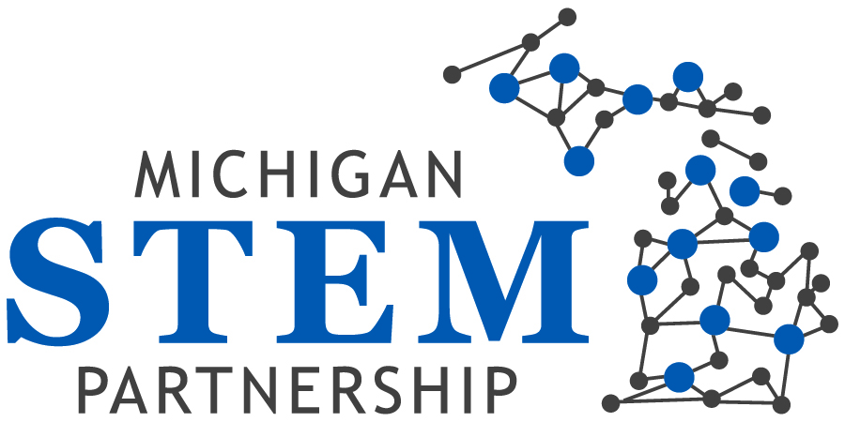

Minutes of Board meeting 2/27/14

Meeting convened at 12:19 p.m.

Chair reminded all members that meetings are scheduled to begin at noon with a 3 p.m. end time. The last few meetings have each convened approximately 15 minutes late, and Chair said that she would send out a message to all members stressing the need to convene on time.
Attendees: Paul Agosta; Joe Asiala; Patty Cantu; Christy-Cloud-Webb; Patty Farrell-Cole; Mike Gallagher; Heather Gallegos; Bishop Ben Gibert; Gary Gilger; Alan Lecz; Brandon Lucas; Greg Marks; Val Masuga; Vi ctor Naidu; Megan Schrauben; Jenny Schanker; Mary Sutton; Michael Tanoff; Vass Theodoracatos, Barbara Bolin, Ali K. Elyaderani
Apologies: Derhun Sanders, Jodie Ledford; Bob Warrington

Public Comments: There were no public comments.

Consent agenda: The minutes of the January meeting were approved (Joe/Greg)

Reports:

Executive Committee: The EC has decided to shelve the idea of the Partnership hosting a STEM event this year. Lack of resources (financial and personnel) was cited as the concern. It was agreed however that the Partnership would participate as a partner where possible in other events.
Decisions on sponsoring events will be made by the Communications Committee and perhaps the task force.
The ED asked about hosting a Mid-West STEM Forum in collaboration with the Governor’s office and it was agreed that this would be undertaken only if the Governor provides resources.
About Mid-West Symposium, chair offered bringing communication’s team could be beneficiary.
Because of a conflict with the US News STEM Solutions conference and the Governor’s Education Summit, the EC decided to cancel the April Board meeting.
The Chair suggested that because the committees are now active and working well, the Board could change its schedule to meetings every alternate month. After a short discussion the motion was approved.
The ED will make this change on the events page of the web site. Reminders and call-in information will also be updated for members.
Ali was asked to send the meeting schedule with calling number for the rest of the 2014 board meetings.
Ali and Greg titled to prepare resources on communication.
Strategic Direction Committee: Paul presented the suggested goals and strategies that resulted from two meetings of the committee. He explained that the committee had combined previous goals 3 and 5, resulting in the four goals presented. Supporting strategies were also presented to the Board.
Discussion followed on the following questions and topics:
- Is the emphasis on K-12 or on post-secondary education? (Greg). Mike pointed out that the lines must be blurred between the two. Vass indicated that our mission and vision are based on the P-20 system so he recommended that that is where the Board should begin and that we should learn as we move forward how to foster smooth transitions and connections to encourage a pipeline concept in education.
- Are we adequately supporting the NGSS? The Board supplied a letter of support for NGSS to the State Board of Education in 2013.
- Heather suggested we need to have sort of measurement assigned to our goals and make it clear who is going to be responsible for those goals.
- How will the Board use the completed document? (Mary). Brandon/Mary suggested that the Board use the document to assist with recognition of exemplary programs and partners.
- Some wording in the strategies was modified.
- Input should be requested from the hubs, and efforts be made to align the Board goals with those of the hubs.
- The Strategic Direction committee will continue its work on the strategies, moving forward into possible metrics.
- It was agreed that ownership for each strategy be identified and that a scorecard be developed.

Paul emphasized that the proposed strategies are those for the Board.
The 4 goals were approved as modified (Greg/Megan).

The order of the agenda was modified at this time to accommodate a presentation by Amy Cell and John Redwine of the MEDC.

Amy reminded the Board that the Governor has requested that all government agencies work through a 10 region model. These regions are called prosperity/economic development/talent regions. The map showing the overlap of these regions and the 5 STEM hubs was presented to the Board.
Amy shared that the MEDC will use $150K to bring together all stakeholders in these regions for programs and projects that must be completed by September 30, 2014. She invited the Partnership to be a collaborator in this effort that will be led by the Michigan Works! Association (as the fiscal agent), the Educational Advisory Groups, the MWAs, and the Partnership. She indicated that the funds will be used strategically in the regions, and that there should be more to come in the future to the benefit of the STEM hubs and the Partnership infrastructure.
Amy is anxious to bring representatives of the STEM hubs into regional discussions and meetings. The ED will work closely with MEDC to provide a list of hub representatives, preferred programs, and eligible applicants. A meeting will be organized in the near future to better engage service providers.
Amy and John left the meeting and the Board took a short break.
Lively discussions resumed after the break on the following topics:
- The opportunity that the Board had been given to participate as a partner with MEDC in efforts to balance the supply-demand equation. It was agreed that the Partnership brings the supply side to the MEDC demand side, and that will give us access to employers and possible funding.
- Mary commented that the Partnership has a broad focus and that we can use and strengthen our own network.
- Should the Board order our strategies to reflect this new emphasis, and should we concentrate our efforts on programs that work? Joe pointed out that through this new collaboration with MEDC, we will have access to the future workforce through education.
- It was reiterated that a scorecard is important to keep us on track.
- The current connection between the Board and the hubs is weak and this must be a priority for the Board. Board cleared out that, we need to make sure any grant we pursue is toward following our strategic plans.
- Hub should be participated more with STEM partnership.
- Future funding opportunities through MEDC must align with our goals and metrics. We must protect our interests and basic charter (Brandon).
- Barbara mentioned that the presentation at the booth (MSTA meeting-Lansing Center- March 7th) will be about giving more guidelines and clarification about requirements.
- Christy pointed out that hub liaisons will find it difficult to attend prosperity regions meetings.

The Board returned to the planned agenda with limited time available.

Board Development Committee: Because of the lengthy discussion and consequent shortage of time, the report from the Board Development Committee was postponed.

Communication Committee: The report of two meetings of the committee was provided in written form.

Task Force: The grants program will be rolled out during a presentation by Megan and the ED at the MSTA conference on Friday March 6. The Partnership will have an exhibit at the conference. Board members are invited to attend. Documentation for the program includes the RFP, evaluation rubric, a guidelines document, and a standard title page. All information will be available as handouts, and also on the web site. Announcements will be made through LinkedIn, Twitter, the newsletter, and direct e-mailing. Hubs will do marketing in their regions.

Executive Director’s report: This was provided in written form and so detailed discussion was postponed. The ED showed the new STEM & Me pages on the web site, including photos from the Feb 11 presentations at the SBE meeting.

Next meeting: March 27

The meeting adjourned at 3:15 p.m.

